DRDO SENSOR INTEGRATION PROJECT
Prerequisite Learning Module — Frontend Learning
Frontend Communication & Desktop
Dashboard — Learning Session Report
A proof-of-concept study of Python ↔ React WebSocket communication
and the Electron desktop shell, ahead of integrating the real sensor backend
Technology stack: Python · asyncio · websockets · React 19 · Vite · Electron
Prepared by
Tejas
B.Tech Computer Science · Samrat Ashok Technological Institute, Vidisha
September 2026

Table of Contents
1. Introduction
2. Objectives
3. Technology Overview
4. React + Vite Foundation
4.1 / 4.2 Project Structure · Configuring Vite for Desktop File Loading
5. Electron Foundation
6. electron/main.cjs — Detailed Walkthrough
7. electron/preload.cjs — Detailed Walkthrough
8. Why .cjs? (CommonJS vs. ES Modules)
9. Python WebSocket Backend
10. JSON Data Flow
11. React WebSocket Client
12. Electron + Vite Development Flow
12.1–12.3 cross-env · concurrently · wait-on
13. Errors and Problems Encountered
14. Why WebSocket in the Prototype
15. Development vs. Production
16. Small Project Architecture
17. Connection to the Big Project
18. Updated Big Project Architecture
19. Complete Data Flow Example
20. Learning Outcomes
21. Conclusion

1. Introduction
The larger DRDO sensor integration project requires a desktop dashboard capable of receiving and displaying real-time sensor information. That dashboard sits at the end of a longer pipeline: physical sensors, communication interfaces, a Python acquisition and normalization layer, and an MQTT-based transport, all of which are handled entirely on the backend.
Before wiring the dashboard to that real pipeline, a small, self-contained prototype was built to isolate and validate just the last link of the chain — getting live data from a Python process into a desktop window built with React, Vite and Electron. This report documents that prototype: what was built, why each technology was chosen, how the pieces communicate, what went wrong along the way, and how the result maps onto the bigger project.
This is a technical learning report, not a tutorial rewritten from documentation — every code excerpt, configuration value and screenshot in this document is taken from the actual implementation.

2. Objectives
The learning session was structured around the following objectives:
- Understand the React + Vite project structure and how the two tools relate to each other.
- Understand Electron’s process model — the main process, the renderer, and the preload bridge between them.
- Establish a secure communication path between Electron and the frontend, without exposing Node.js to the UI.
- Build a working Python ↔ frontend communication channel using WebSocket.
- Transfer structured telemetry as JSON and display it live in a React component.
- Understand the difference between the development and production run modes of an Electron + Vite application.
- Relate this small prototype back to the architecture of the larger sensor project.

3. Technology Overview
The table below separates what this prototype actually uses from what belongs to the larger project. Nothing in the second column has been implemented in this learning session — it is included only to show where each technology from the prototype eventually fits.
Technology | Purpose in this prototype | Purpose in the big project
Python | Runs a single asyncio WebSocket server that generates sample telemetry. | Runs sensor acquisition, vendor-specific conversion, and MQTT publishing.
WebSocket | The only transport used — connects the Python server directly to the React client. | The final hop from the backend subscriber to the frontend, after MQTT.
JSON | Wire format for the telemetry payload (temperature, humidity, status). | Wire format for normalized sensor readings, both on MQTT and on WebSocket.
React | Renders the dashboard from two pieces of state. | Unchanged — same dashboard, fed by real data instead of random data.
Vite | Development server and production bundler for the React source. | Unchanged.
Electron | Hosts the React app as a desktop window; owns the main/preload/renderer split. | Unchanged.
Node.js / npm | Runtime for Vite/Electron tooling and dependency management. | Unchanged.
MQTT | Not used anywhere in this prototype. | Backend-internal transport between the converters and the subscriber.
TCP/IP · Serial · RS485 · Modbus | Not used anywhere in this prototype. | Physical/transport layer between real sensors and the Python backend.

Scope, stated plainly
This prototype exercises only the WebSocket → React → Electron segment of the pipeline. MQTT, sensor acquisition and data normalization belong to the backend already built in Main Project v4 and are not part of this learning session.

4. React + Vite Foundation
React is a library for describing a user interface as a tree of components; it knows about components, state and rendering, and nothing about files, servers or bundling. Vite is the development server and build tool that turns the React source into something a browser (or, here, an Electron window) can actually load. The two are complementary, not competing — one is the UI library, the other is the tool that serves and builds it.
The project was created with the official scaffolding command, which sets up a minimal React + Vite starter and installs its dependencies:
C:\Users\tejas\Desktop\DRDO\Prerequisites\Frontend Learning> npm create vite@latest Test_Prog -- --template react
Command used to scaffold the project.
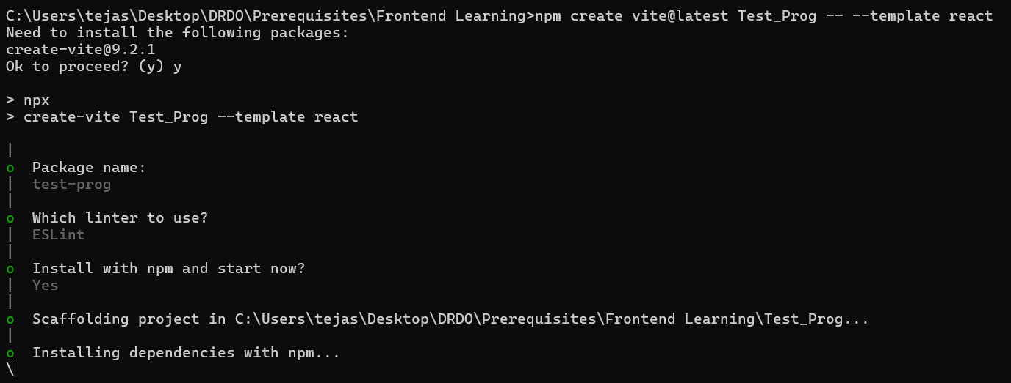
Figure 1: Vite scaffolding a new React project named Test_Prog.
Once scaffolded, npm run dev starts the Vite development server, which by default serves the app at http://localhost:5173 with Hot Module Replacement (HMR) — saved edits appear in the browser without a manual reload.
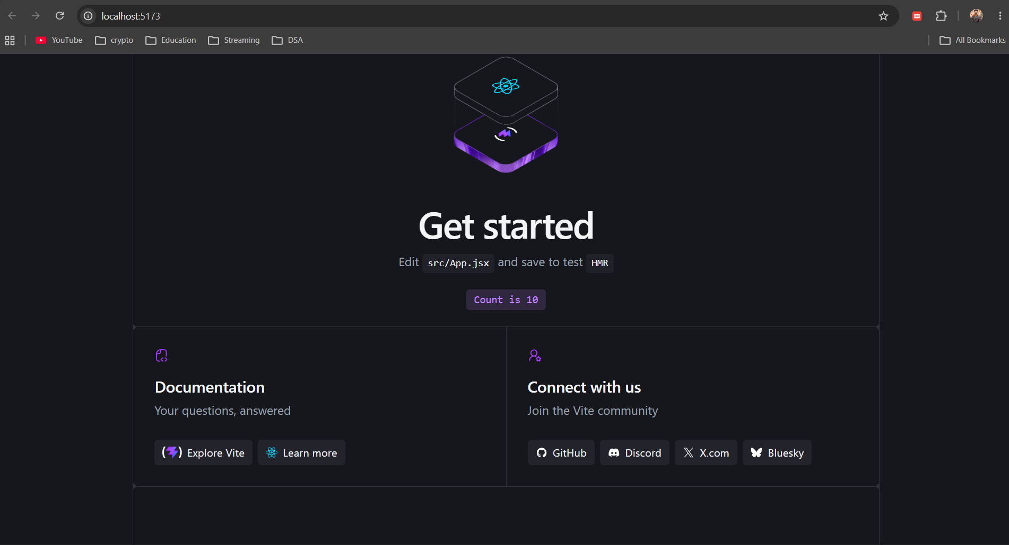
Figure 2: The default Vite + React starter page, running at localhost:5173.

4.1 Project structure
The relevant parts of the generated structure are:
Test_Prog/
src/
main.jsx entry point — mounts <App /> into the DOM
App.jsx the dashboard component (Section 11)
electron/
main.cjs Electron main process (Section 6)
preload.cjs secure bridge (Section 7)
index.html HTML shell Vite injects the bundle into
vite.config.js Vite configuration (Section 4.2)
package.json dependencies and npm scripts

4.2 Configuring Vite for desktop file loading
By default, Vite emits asset paths rooted at "/", which is correct for a web server but wrong for a file opened directly from disk. Electron’s production build loads index.html with the file:// protocol, so absolute paths silently fail to resolve. Adding base: './' switches every asset reference to a relative path, which resolves correctly however the file is opened.
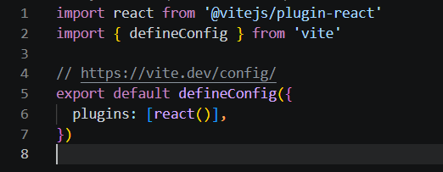
Figure 3: vite.config.js before the change — default (absolute) asset paths.
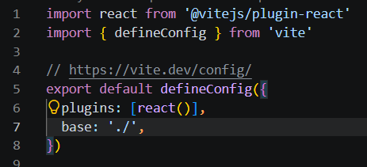
Figure 4: vite.config.js after adding base: './'.
Why this matters
Without base: './', the production build works when served by Vite’s own dev server (which understands absolute paths) but shows a blank window when Electron loads the built file directly from disk in production.

5. Electron Foundation
The dashboard is meant to be operated on a machine alongside the backend, not visited as a website, so it is packaged as a desktop application using Electron. Electron combines Chromium (to render the UI) with Node.js (to host the application process), and splits every app into two kinds of process:
Electron Main Process
|
v
BrowserWindow
|
v
React Application (renderer)
Figure 5: Electron’s process structure.
- The main process (main.cjs) is a Node.js process. It creates the application window and controls the app’s lifecycle.
- The renderer is the Chromium context that actually displays the React UI — from the operating system’s point of view, it is just a web page.
- The preload script (preload.cjs) runs before the renderer’s page scripts, with one foot in each world, and is the only sanctioned way to pass capabilities from the main process to the UI.

6. electron/main.cjs — Detailed Walkthrough
The full file, exactly as implemented:
const { app, BrowserWindow } = require('electron');
const path = require('path');
function createWindow() {
const win = new BrowserWindow({
width: 1100,
height: 750,
webPreferences: {
preload: path.join(__dirname, 'preload.cjs'),
contextIsolation: true,
nodeIntegration: false,
},
});
const isDev = process.env.NODE_ENV === 'development';
if (isDev) {
// Connect to Vite server during development
win.loadURL('http://localhost:5173');
} else {
// Load static built files in production (No server required)
win.loadFile(path.join(__dirname, '../dist/index.html'));
}
}
app.whenReady().then(createWindow);
app.on('window-all-closed', () => {
if (process.platform !== 'darwin') app.quit();
});
Figure 6: electron/main.cjs in full.

6.1 require('electron') and require('path')
app controls the application’s lifecycle (ready, quit, activate events); BrowserWindow is the class used to create and manage a native window. path.join builds file paths that work the same way on Windows, macOS and Linux, which matters because __dirname resolves differently across build and run locations.

6.2 createWindow() and the BrowserWindow configuration
The window is fixed at 1100×750, sized for a dashboard rather than a resizable general-purpose window. The three webPreferences entries are a deliberate security posture, expanded in Section 7: a preload script is attached, context isolation is turned on, and Node integration in the renderer is turned off. Without these three lines, any script running in the dashboard — including a bug in a future dependency — would have unrestricted access to the file system and shell.

6.3 The development / production branch
isDev reads the NODE_ENV environment variable set by the npm script that launches the app (Section 12). In development, the window points at the URL Vite’s dev server is serving, so edits to the React source are reflected immediately. In production there is no server at all: the window opens the built index.html file directly from the dist/ folder produced by vite build. This is the same distinction covered in Section 4.2 — base: './' is what makes the file:// load in this branch actually work.

6.4 app.whenReady() and window-all-closed
app.whenReady() resolves once Electron has finished its own startup, and only then is it safe to create a window. window-all-closed quits the app when every window is closed, except on macOS (darwin), where the platform convention is for an app to keep running until the user explicitly quits it from the dock.
What would happen without this
Without the isDev branch, the window would try to load one fixed target — either always failing in development (no dist/ folder yet) or always failing in production (no dev server running). The branch is what lets the same file work in both situations.

7. electron/preload.cjs — Detailed Walkthrough
The full file:
const { contextBridge } = require('electron');
contextBridge.exposeInMainWorld('electronAPI', {
platform: process.platform,
});
Figure 7: electron/preload.cjs in full — the entire bridge.
The renderer runs the React application, which is ultimately just web content — giving it direct Node.js access (nodeIntegration: true) would mean any script it ever loads, including a compromised or buggy dependency, could read and write files or spawn processes on the host machine. Two settings close that door, and one script deliberately reopens a narrow slit in it:
- nodeIntegration: false removes Node.js access from the renderer entirely.
- contextIsolation: true keeps the preload script’s JavaScript context separate from the page’s own scripts, so the page cannot reach into preload’s variables even indirectly.
- contextBridge.exposeInMainWorld(...) is the one sanctioned crossing point: it publishes a specific, named object onto the page’s window under a chosen key — here, window.electronAPI — and nothing else.
In this prototype the bridge exposes exactly one value, process.platform (the host OS identifier), and nothing else — no file access, no IPC channel, no shell access. That is deliberate: the dashboard’s data arrives entirely over the WebSocket connection set up in React (Section 11), so it has no need to reach into Electron or the operating system at all.
React component
|
v
window.electronAPI
|
v
preload.cjs (contextBridge)
|
v
Electron main process
Figure 8: the only access path from the UI back into Electron.

8. Why .cjs? (CommonJS vs. ES Modules)
Test_Prog/package.json declares "type": "module", which tells Node.js to treat .js files in the project as ES Modules — the import / export syntax that React source uses throughout. Electron’s own runtime for the main and preload scripts, however, is written against CommonJS — require() and module.exports.
 | CommonJS | ES Modules
Import | const { app } = require('electron'); | import { app } from 'electron';
Export | module.exports = value; | export default value;
Used by | main.cjs, preload.cjs | App.jsx, main.jsx

Naming a file .cjs is an explicit override: regardless of the "type": "module" setting for the rest of the project, Node treats any .cjs file as CommonJS. This lets Electron’s two process-level scripts keep using require(), while every React source file continues to use import / export, without the two conventions colliding.

9. Python WebSocket Backend
The prototype’s backend is a single Python file, Basic Backend/backend.py, built on asyncio and the websockets library:
import asyncio
import json
import random
import websockets
async def handle_connection(websocket):
print("[Python] Electron app connected!")
try:
while True:
# 1. Prepare data payload
payload = {
"temperature": round(random.uniform(20.0, 30.0), 1),
"humidity": round(random.uniform(40.0, 60.0), 1),
"status": "Active"
}
# 2. Send JSON string over WebSocket
await websocket.send(json.dumps(payload))
print(f"[Python] Sent: {payload}")
# 3. Wait 2 seconds before sending next update
await asyncio.sleep(2)
except websockets.exceptions.ConnectionClosed:
print("[Python] Electron app disconnected.")
async def main():
print("[Python] Starting WebSocket server on ws://localhost:8765...")
async with websockets.serve(handle_connection, "localhost", 8765):
await asyncio.Future() # Keep server running forever
if __name__ == '__main__':
asyncio.run(main())
Figure 9: Basic Backend/backend.py in full.

9.1 Why Python
Python was chosen for consistency with the rest of the backend, which already uses Python for sensor acquisition and MQTT handling in the larger project (Section 17). Its websockets library gives a complete async server in a handful of lines, and asyncio’s cooperative concurrency model is a natural fit for a process that has to wait on I/O — network sockets today, sensor links in the full system — without blocking.

9.2 Reading the connection handler
- websockets.serve(handle_connection, "localhost", 8765) starts the server and calls handle_connection once for every client that connects.
- The while True loop runs for the lifetime of that one connection, building a fresh payload dictionary on every iteration.
- round(random.uniform(20.0, 30.0), 1) stands in for a real sensor reading — it is explicitly simulated, not measured (see Section 16).
- json.dumps(payload) serializes the Python dictionary to a JSON string before it goes on the wire; websocket.send() only sends text or bytes, not Python objects.
- asyncio.sleep(2) yields control for two seconds without blocking the event loop, which is why the server could in principle serve several clients at once.
- The try/except around the loop catches ConnectionClosed so that the Electron app closing its window does not crash the server — it simply logs the disconnect and the coroutine ends.

10. JSON Data Flow
The payload actually used in this prototype is intentionally small:
{
"temperature": 27.9,
"humidity": 42.9,
"status": "Active"
}
Figure 10: one telemetry payload, as actually sent.
JSON is the structured format carried across the boundary between the two languages. The complete journey of one payload is:
Python builds a dict
|
v
json.dumps(payload) -> JSON string
|
v
websocket.send(...) -> sent over the open connection
|
v
React: ws.onmessage(event) -> event.data is the JSON string
|
v
JSON.parse(event.data) -> a plain JavaScript object
|
v
setSensorData(received) -> React state updated
|
v
Component re-renders -> new values appear on screen
Figure 11: one reading, from Python dictionary to rendered pixels.
Every arrow in that chain is a real conversion: a Python dict is not a JSON string until json.dumps runs, and a JSON string is not a JavaScript object until JSON.parse runs on the other side. Skipping either step is the most common source of bugs when wiring a new WebSocket payload.

11. React WebSocket Client
The dashboard is a single component, src/App.jsx:
import { useEffect, useState } from 'react';
function App() {
const [sensorData, setSensorData] = useState(null);
const [connectionStatus, setConnectionStatus] = useState('Connecting...');
useEffect(() => {
// Connect to Python WebSocket server
const ws = new WebSocket('ws://localhost:8765');
ws.onopen = () => setConnectionStatus('Connected');
ws.onclose = () => setConnectionStatus('Disconnected');
ws.onmessage = (event) => {
// Parse JSON payload sent from Python
const received = JSON.parse(event.data);
setSensorData(received);
};
// Cleanup connection when React component unmounts
return () => ws.close();
}, []);
return ( /* dashboard markup — status line + metric cards */ );
}
export default App;
Figure 12: src/App.jsx (markup abbreviated; logic shown in full).

11.1 State
Two pieces of state are enough for the whole dashboard: sensorData holds the most recent payload (or null before the first message arrives), and connectionStatus tracks whether the socket is connecting, connected, or disconnected, driving the coloured status text visible in Figure 20.

11.2 The effect and its dependency array
useEffect(() => { ... }, []) with an empty dependency array runs its setup function exactly once, when the component first mounts, and its cleanup function exactly once, when the component unmounts. That is what keeps this to one WebSocket connection: without the empty array, the effect would re-run — and open a new connection — on every re-render, which happens every time setSensorData fires.

11.3 The event sequence
React component mounts
|
v
new WebSocket(...) opens the connection
|
v
Python server accepts the connection
|
v
ws.onopen fires -> status set to "Connected"
|
v
Python sends JSON every 2 seconds
|
v
ws.onmessage fires -> JSON.parse -> setSensorData
|
v
React re-renders -> new values appear on the dashboard
Figure 13: the complete sequence, one connection, repeating updates.

11.4 Cleanup
return () => ws.close() closes the socket when the component unmounts. Skipping this is a common source of leaked connections in React — without it, navigating away and back would open a second socket on top of the first.

12. Electron + Vite Development Flow
Running the app during development means two independent processes need to be running at once: the Vite dev server, and the Electron window that loads from it — and Electron must not start before Vite is ready. A single npm script chains three small tools together to make npm run electron:dev do all of that reliably, in one step:
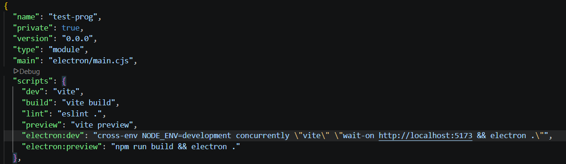
Figure 14: the relevant scripts in Test_Prog/package.json.
"electron:dev": "cross-env NODE_ENV=development concurrently \"vite\" \"wait-on http://localhost:5173 && electron .\""
Figure 15: the electron:dev script in full.

12.1 cross-env — setting NODE_ENV portably
The syntax for setting an environment variable inline differs between Windows and Unix-like shells — NODE_ENV=development works on macOS/Linux but is not valid syntax in the default Windows command prompt. cross-env NODE_ENV=development normalizes this into one syntax that works on any platform the script is run on, which is exactly the isDev check read back in main.cjs (Section 6.3).

12.2 concurrently — running two commands at once
Without it, starting the app during development would need two separate terminals — one running the Vite dev server, one running Electron. concurrently "vite" "wait-on ... && electron ." launches both commands in parallel from a single npm script.

12.3 wait-on — avoiding a race condition
Electron and Vite start at effectively the same instant under concurrently. If Electron tried to load http://localhost:5173 immediately, it would very likely fail, because Vite has not finished starting its server yet. wait-on http://localhost:5173 blocks until that URL responds, and only then does && electron . run — turning a race condition into a guaranteed order.
concurrently starts both:
"vite" "wait-on http://localhost:5173 && electron ."
| |
v v
Vite server starts wait-on polls the URL
| |
v |
localhost:5173 is live ------------------+
|
v
electron . starts,
loads a server that is
now guaranteed to be ready
Figure 16: how the three tools resolve the startup race.

13. Errors and Problems Encountered
One concrete error was hit and resolved during this session:
'cross-env' is not recognized as an internal or external command,
operable program or batch file.
Figure 17: the error, as it appeared in the terminal.

13.1 Cause
The electron:dev script calls cross-env, but cross-env is a separate npm package — it is not part of Node.js or npm itself. The command failed because that package had not yet been installed as a project dependency.

13.2 Fix
Installing the missing dependency resolved it:
npm install --save-dev cross-env

After the install, npm run electron:dev completed successfully, launching both the Vite server and the Electron window as intended.
Note on scope
This is the one error captured in the source material for this session. No other failures are documented here — the report does not invent additional problems beyond what actually occurred.

14. Why WebSocket in the Prototype
A WebSocket connection is opened once and stays open for as long as both ends want it, carrying messages in either direction over that single connection (full-duplex), with far less overhead per message than repeatedly opening a new HTTP request.
 | HTTP polling | WebSocket (used here)
Connection | Opened and closed for every request | Opened once, stays open
Who initiates each update | The client, by asking again | The server, the moment it has data
Typical latency | Up to one full poll interval | Near-immediate
Overhead per update | Full HTTP request/response headers | A small message frame

For a dashboard that is meant to feel live, the difference matters: polling either wastes requests asking for data that has not changed, or lags behind by however long the poll interval is. A WebSocket server can push a reading the instant it exists, which is what backend.py does every two seconds.

15. Development vs. Production
 | Development | Production
React source served by | Vite dev server (npm run dev) | Nothing — already built
Electron loads | http://localhost:5173 | dist/index.html, via loadFile
Edits appear via | Hot Module Replacement | A fresh build (vite build)
Requires base: './'? | No — absolute paths resolve fine against a server | Yes — or asset paths fail against file://
Launched by | npm run electron:dev | npm run electron:preview

DEVELOPMENT
React source -> Vite dev server -> http://localhost:5173 -> Electron
PRODUCTION
React source -> vite build -> dist/index.html -> Electron
Figure 18: the same React source, two different delivery paths.
In this prototype only the development path (npm run electron:dev) has actually been run — there is no dist/ folder yet, so the production build is configured (Section 4.2, Section 6.3) but has not been exercised end-to-end.

16. Small Project Architecture
Python backend (backend.py)
|
| WebSocket / JSON, every 2s
v
React frontend (App.jsx)
|
v
Electron desktop application
Figure 19: the prototype in full — every box shown here has actually been run.
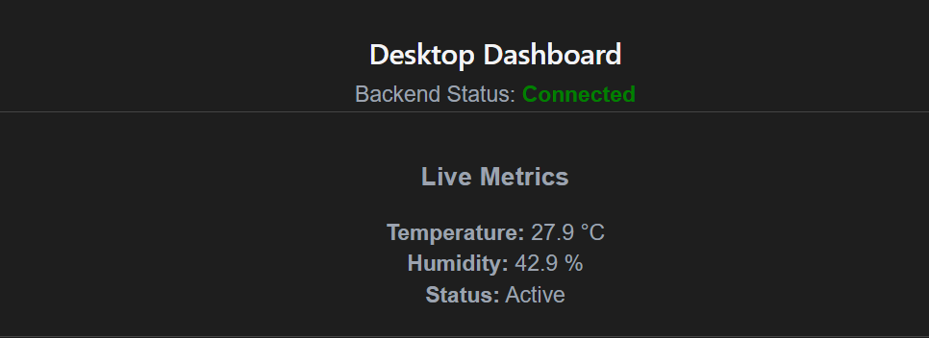
Figure 20: the running Electron window, showing live simulated values.
Scope, stated plainly
The Python program generates random temperature and humidity values — it does not read a sensor, and MQTT does not appear anywhere in this prototype. That was the point: validate the backend-to-frontend transport and the desktop shell on their own, before connecting them to the real acquisition pipeline.

17. Connection to the Big Project
The small prototype is a simplified version of exactly one part of the big project’s architecture — the last hop, from a backend process to the dashboard.
 | Small prototype | Big project
Python | Generates random telemetry | Runs sensor acquisition, conversion and MQTT
Transport to frontend | WebSocket, JSON | WebSocket, JSON (same mechanism)
Frontend | React + Vite + Electron | React + Vite + Electron (same stack)
What the frontend knows about sensors | Nothing | Nothing (unchanged by design)

17.1 What carries over directly
- The backend produces data and hands it to the frontend over a persistent connection.
- The data is structured as JSON before it is transported.
- React receives it, updates state, and the dashboard re-renders automatically.
- Electron provides the desktop shell around the same React code either way.

17.2 What changes
- The prototype uses generated random data; the big project uses real sensor readings.
- The prototype has one Python WebSocket server; the big project has multiple sensor communication mechanisms feeding a converter layer.
- The big project routes data through MQTT entirely on the backend before it ever reaches a WebSocket.
- The frontend does not need to understand individual sensor protocols in either case — it only ever receives normalized, display-ready values.

18. Updated Big Project Architecture
The architecture for the full project has been clarified since earlier stages: Electron and React will not connect to MQTT directly. MQTT communication is handled entirely on the Python backend; the frontend’s only responsibility is to receive already-processed data and display it.
PHYSICAL SENSORS
|
+-----------------+------------------+
v v v
Ethernet Serial RS485
| | |
+-----------------+------------------+
v
Python Backend
v
Universal Converters
v
Data Normalization
v
MQTT Broker
v
Backend Subscriber / Processing /
Forwarding
v
Frontend Communication
(WebSocket)
v
Electron
v
React
v
Dashboard
Figure 21: the updated architecture — MQTT stops at the backend subscriber.
Architectural rule
MQTT stops at the backend side. Electron and React do not directly connect to MQTT. Previously the frontend subscribed to the broker on its own, which meant the dashboard could fail independently of the backend — two separate points of failure for one reading. The frontend now receives only what the backend has already processed and forwarded.

19. Complete Data Flow Example
Tracing one sensor reading through the full, updated architecture, end to end:
# | Step | What happens
1 | Sensor measures a value | A field device takes a reading and emits it on its own physical link.
2 | Interface carries raw data | Ethernet, serial or RS485 carries the raw, uninterpreted signal.
3 | Python receives it | The connection handler for that sensor reads the frame off the socket.
4 | Converter interprets the format | Vendor-specific parsing turns the frame into named values with units.
5 | Data is normalized | The reading is written into the common structure shared by every sensor.
6 | Backend publishes to MQTT | The normalized reading is sent to the broker on the sensor’s topic.
7 | Backend subscriber receives it | The subscriber, holding a matching topic filter, receives the message.
8 | Backend forwards to the frontend channel | The relevant value is handed to the WebSocket-serving process.
9 | Frontend receives JSON | The React client’s onmessage handler fires with the serialized payload.
10 | React updates state | JSON.parse builds the object; setSensorData stores it.
11 | Dashboard displays the new value | React re-renders; the operator sees the update.

Steps 1–8 are backend work, entirely inside Python and MQTT. Steps 9–11 are the frontend path already built and proven in this prototype (Sections 9–11) — only the source of the data changes between the two.

20. Learning Outcomes
This session produced concrete, transferable understanding across both ends of the stack:
- React component structure, state and the render lifecycle.
- WebSocket communication as a persistent, full-duplex alternative to polling.
- JSON serialization and deserialization across a language boundary (Python ↔ JavaScript).
- Electron’s process model — main process, renderer, and the preload security boundary between them.
- Vite’s role as a development server and build tool, distinct from React itself.
- npm dependency management, including a real missing-dependency error and its fix.
- The practical difference between a development run and a production build for the same codebase.
- Backend/frontend separation of concerns — the frontend never needs to know how the data behind a value was produced.
- Data-flow thinking: tracing one value all the way from its source to the screen, and identifying exactly where each transformation happens.

21. Conclusion
This learning session built and validated the last link of the sensor project’s data pipeline in isolation: a Python process pushing structured JSON over a persistent WebSocket connection, a React component turning that into live state, and Electron hosting the result as a desktop application. Every piece of this prototype — the WebSocket server, the React client, the Electron shell, its development tooling, and the one error encountered along the way — has been run and observed directly, not merely read about.
None of this makes the sensor data real, and it deliberately does not touch MQTT, acquisition or normalization, all of which already exist in the backend built for Main Project v4. What it establishes is that the remaining piece — getting a value out of the backend and onto the screen — is understood and working, which is exactly the foundation needed to connect the dashboard to the real backend/sensor architecture next.

